Request to continue prescribing of in primary care

Information for the GP Practice

Specialist | GP Details | Patient details
Name: Dr Dennis Grigoratos | Name:  Address:  Tel:  Fax:  Nhs.net email: | Surname:  Forename:  DOB:  Address:  NHS no:
Clinic initiating: PRUH Paediatrics
Tel: 01689864842
Fax: n/a
Email: dionysios.grigoratos@nhs.net

Dear Doctor,

Your above patient has been started on XXX for the management of XXXX.

The patient has completed a period of treatment under Specialist care and as per South East London Area Prescribing Committee (SEL APC) recommendations we now request you to take over prescribing and management of this medicine.

I confirm that the patient:

1. | Has been initiated on the above medication in line with SEL APC recommendations for this drug | X
2. | Has tolerated the treatment well and there are no concerns about adverse effects | X

Note: The specialist completing this form MUST answer the X questions above before sending this request to the practice

Further information: any responsibility for patient monitoring parameters for the above medication remains with our service.

Please contact me via the contact details above if you have any questions about the treatment of this patient or the information contained in this letter.

Yours sincerely,

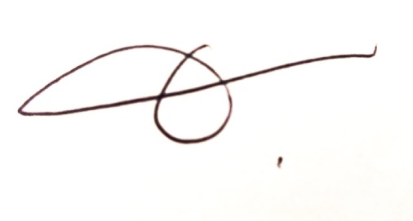

Dr Dennis Grigoratos BSc(Hons) MBBS (Lon) MRCPCH, Consultant Paediatrician

GP PRACTICE RESPONSE: to be completed and signed by the GP if NOT willing to take on prescribing
responsibility and returned to the specialist:
This is to confirm that I am not willing to accept prescribing responsibility for the above medication(s) for this patient for the following reason:
…………………………………………………………………………………………………………………………..

GP name: ………………………………GP signature: ………………………………………………Date: ……/….…/…....

